**Dot Net [C#]**

**Dot Net –**

* **.NET** is developed by **Microsoft.**
* .NET is a collection of Languages and framework.
* Possible to Develop Console Application, Windows Application, Web Application, Mobile Application.

C programming ----------🡪 C# .NET

C and C++ programming -----------🡪 C# .NET

Java Programming ----------🡪 J# .NET 🡨-------------- .NET

Visual Basic ----------🡪 VB.NET

Classic ASP ----------🡪 ASP.NET

**What is DOT NET Framework?**

* The **.NET Framework** is a software development platform of **Microsoft.Net**
* It is a Basically library or collections of libraries.
* Windows Application
* Web Application 🡨-------- .NET Framework
* Mobile Application

**Versions of .NET Framework –**

* **.NET** Framework **1.0** 2002
* **.NET** Framework **1.1** 2003
* **.NET** Framework **2.0** 2005
* **.NET** Framework 3**.0** 2006
* **.NET** Framework **3.5**  2007
* **.NET** Framework **4.0** 2010
* **.NET** Framework **4.5** 2012
* **.NET** Framework **4.5.1** 2013
* **.NET** Framework **4.5.2** 2014
* **.NET** Framework **4.6**  2015
* **.NET** Framework **4.6.1** 2015
* **.NET** Framework **4.6.2** 2016

**Features of .NET –**

* Platform Independent
* Language Independent
* Rich Design
* Garbage Collection
* Object Oriented
* Security
* Easy Database Connectivity

**The Architecture of .NET** –

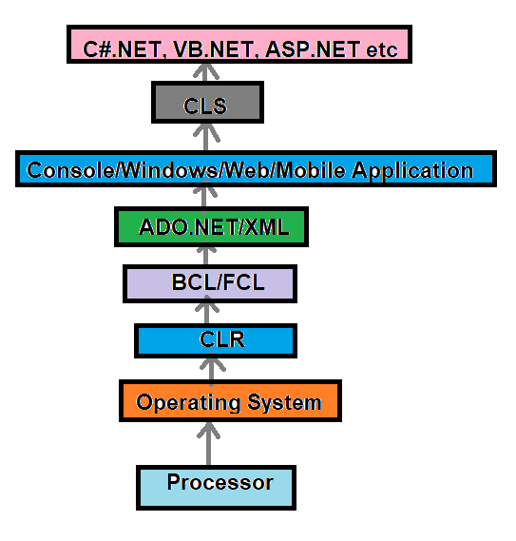

**CIL –**

* Common Intermediate Language (CIL) or Microsoft Intermediate Language (MSIL).
* Plateform Independent

**C programming -------🡪 Machine Language**

**.NET Programming -----🡪 CIL or MSIL ------- CLR ------🡪Machine Language**

**CLR –**

* Common Language Runtime (CLR)
* It is inbuild in .NET.
* It converts CIL to Machine Language.
* CLR is Runtime Engine, Which provide necessary services, while executing the .NET program.
* Just In Time ( JIT ) Compiler – Convert CIL to Machine Language.
* Memory Manager – Allocate Memory
* Garbage Manager – It manages Security
* Class Loader – Loading the class into RAM according to need.

**Framework Class Library (FCL) –**

All Microsoft’s pre-defined libraries are FCL.

* Console Libraries
* Windows Libraries
* Web Libraries

**Base Class Library (BCL) – It is common Library for all Libraries.**

**ADO.NET –**

Database connectivity

FCL

* Console Libraries
* Windows Libraries
* Web Libraries
* ADO.NET

**Base Class Library (BCL) – It is common Library for all Libraries.**

**CLS –**

Common Language Specification (CLS) – Common concepts of various languages.

Ex – Object concept is same for C#.NET, VB.NET etc.

**CTS –**

* Common Type System
* It is part of CLS.
* Common data types of all Languages.

Ex – Char, String, Single, Double etc.

**How to learn Dot Net ?**

**i.) C#**

**ii.) WPF (Windows Presentation Foundar )**

🡪 For this using We can make **Windows applications**

**iii.) ASP.NET Core and .NET MVC**

🡪 For this using we make **Web Application**

**iv.) Database**

**🡪 SQL server**

**🡪MYSQL**

**v.) Database Connectivity**

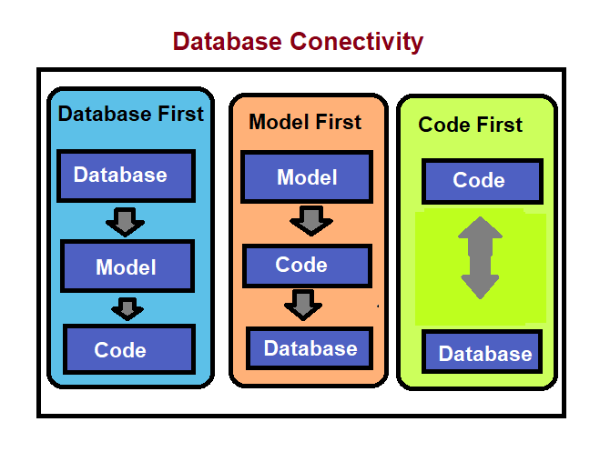

**vi.)**

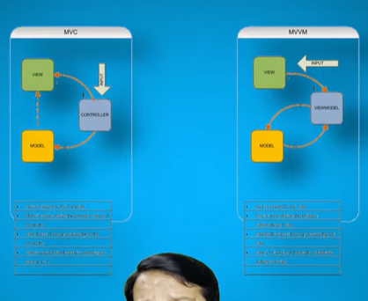

**vi.) Mobile Application**

**🡪 Web API**

**🡪 Resfull API**

**How to work ?**

**1.)**

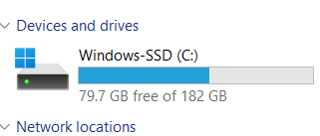

**2.)**

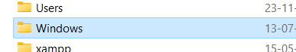

**3.)**

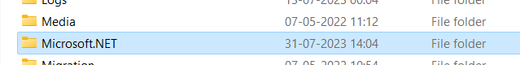

**4.)**

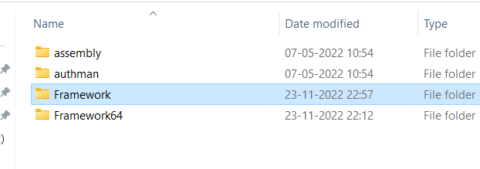

**5.)**

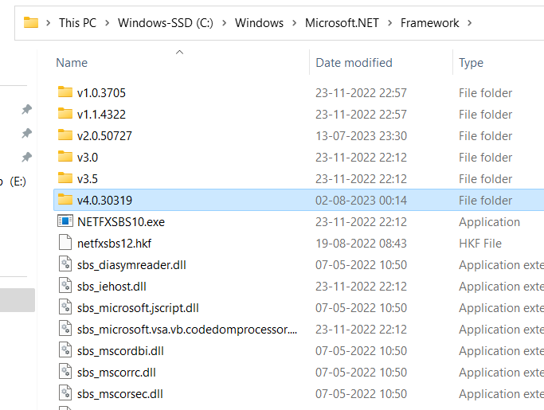

**6.) For set the PATH –**Copy path and Open CMD –

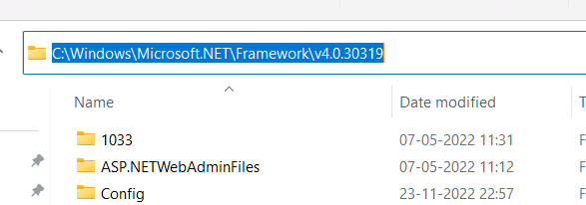

**7.) Cmd –**

**Set path=**

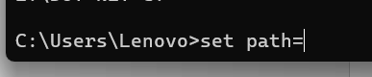

**8.) Paste –**

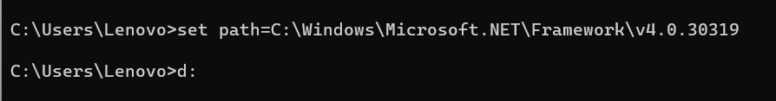

**9.) Open Notepad and write code C#**

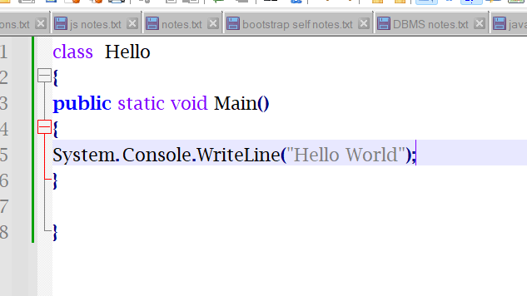

**10.) Save code of C#**

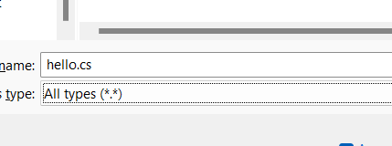

**11.)**

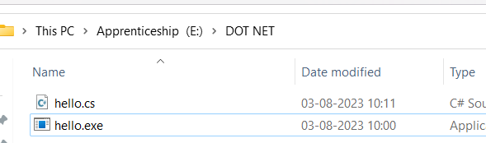

**12.) Running**



**13.)**

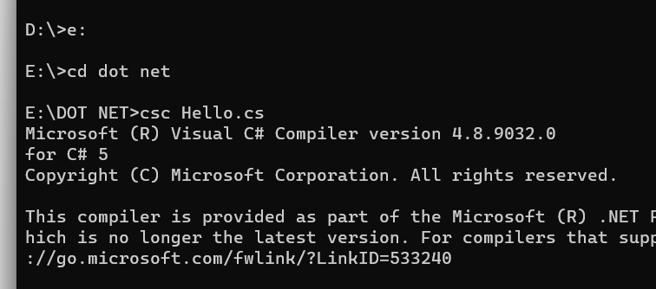

**14.) For execute the program –**

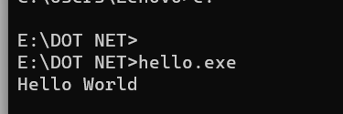

**WPF**

* **WPF** means **windows presentation foundation.**
* It Provide attractive user interface and modern UI display pattern to create desktop application under Microsoft environment.
* WPF is the enchancement of windows Forms Application.
* Windows Forms Application provide Simple User Interface.
* Similar to Windows XP
* But if we want to design Desktop Application similar to windows8, and windows10 UI then we use WPF.
* WPF provide presentation Framework to design rich desktop application.
* It has better graphics (2D,3D) and it work DPI (Dot per inch ) system which is compatible in any device or screen resolutions.

**How to Create WPF Application –**

Step 1: Open Visual Studio

Step 2: Select file 🡪 NEW 🡪Project 🡪 WPF APPLICATION

**What is XAML:**

* It means extensible application markup language which provide design interface and dynamic programming code in WPF Application.
* It Provide data binding, event binding, animation, events.
* It also Provide set of control to design attractive desktop application.

Layout in WPF –

Layout is used to contain various child element of WPF to design WPF application.

It will work as a container control in WPF application.

When we create WPF Application then by default Grid Container will be used.

<window

X:Class=“…..” // Application name

Xmlns=“http://...”

>

</window>

Window is root component of WPF, it contain single layout component using parent with multiple child structure.

Window

Single layout component (Grid, StackPane, WrapPanel)..

Layout1 layout2 layout3 …… or Control

Type of Layout in WPF—

1. Grid panel
2. Wrap panel
3. Dock panel
4. Stack panel
5. Canvas

**Grid panel** –

It is the default layout of WPF application. We can provide rows and columns using Grid Layout.

<Grid.ROWDefinations>

<ROWDefination Width=“” Heigth=“” />

<ROWDefination Width=“” Heigth=“” />

</Grid.ROWDefinations>

<Grid.ColumnDefinations>

<ColumnDefination Width=“” Heigth=“” />

<ColumnDefination Width=“” Heigth=“” />

</Grid.ColumnDefinations>

**Wrap panel** –

**Database Connectivity** –

**Database connectivity using WPF using LINQ** –

* LINQmeans Language Integrated Query it provide new Query Language using programming language **C# and VB.**
* LINQ performance and security is much better as compare to ADO.NET because LINQ Query will be compiled by C# or VB compiler.
* LINQ protect from SQL Injection and other data security problem hence we mostly prefer LINQ for database operation.

🡪*ADO.NET Entity Framework – for Secure to SQL Injection*

* Microsoft provide complete framework to perform LINQ operation.

It is called **ADO.NET Entity Framework**.

**CRUD Operation in WPF using ADO.NET** –

ADO.NET means Active data object, it provide predefined classes and methods to perform database operation.

ADO.NET has different provider for different database server.

**ODBC –** Open Database Connectivity

DSN (Data Source Name) Only for windows

**OLEDB –** Object Linking and Embedding

Oracle, SQL Server, MYSQL

**SQLClient** – It is used for SQL Server or SQL Express or Local DB.

**OracleClient** – It is used for Oracle Database Server

**ADO.NET has four step to perform operations** –

1. Create connection to perform database operation using SQLConnection class
2. Write command to perform database operation using SQLCommand class
3. Execute SQL Query according to command

Insert, Update or Delete -------> ExecuteNonQuery()

Select row -------------------------> ExecuteReader()

Single Scalar value --------------> ExecuteScalar()

1. Create folder

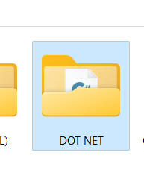

1. Open VS

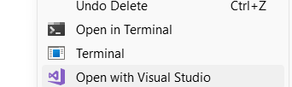

1. For Database

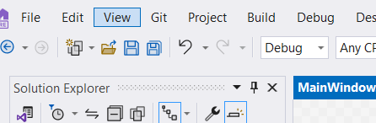

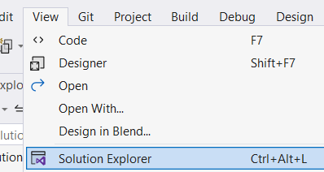

* Right click –
* Go to add
* New item

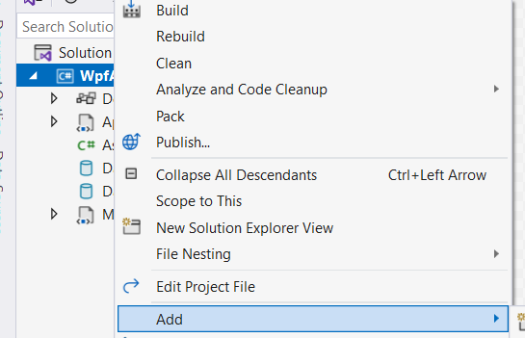

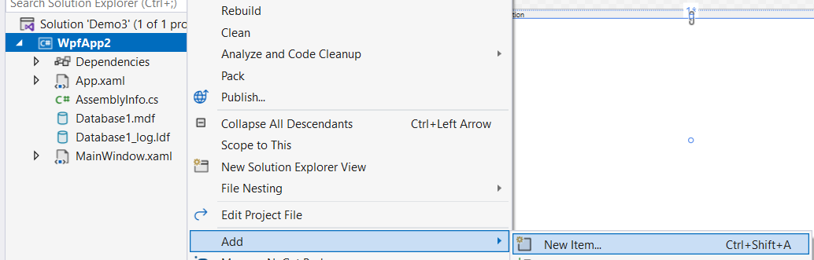

* Data – Database

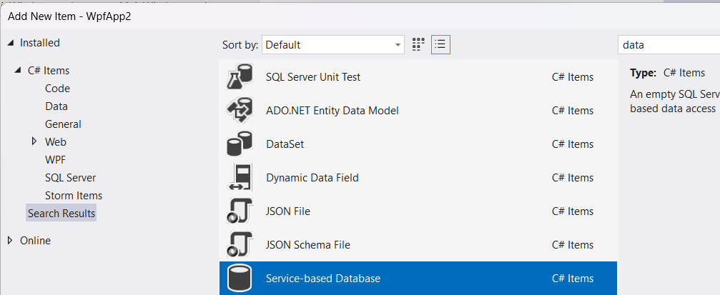

🡪This database is called Local Database.

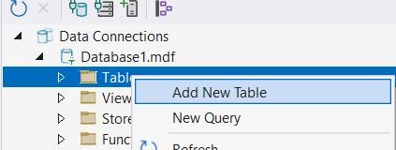

* commands

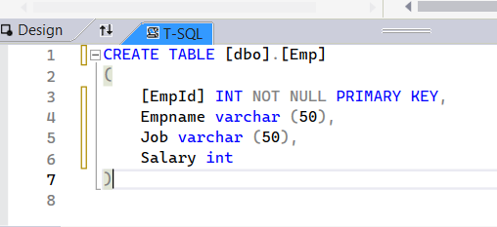

* then click UPDATE

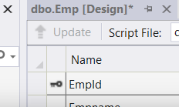

* Click on Update database

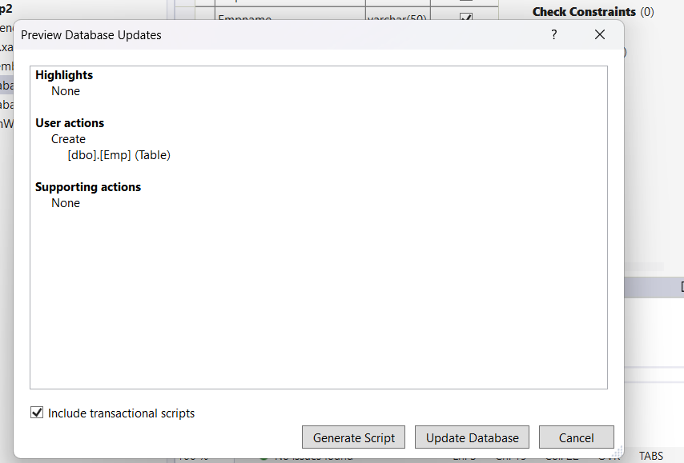

* Show

